**AES Code**

from Crypto.Cipher import AES

from Crypto.Random import get_random_bytes

import base64

def pad(text):

    while len(text) % 16 != 0:

        text += ' '

    return text

def aes_encrypt(key, plaintext):

    cipher = AES.new(key, AES.MODE_ECB)  # ECB for simplicity

    padded_text = pad(plaintext).encode('utf-8')

    ciphertext = cipher.encrypt(padded_text)

    return base64.b64encode(ciphertext).decode('utf-8')

def aes_decrypt(key, ciphertext):

    cipher = AES.new(key, AES.MODE_ECB)

    decoded_ct = base64.b64decode(ciphertext)

    plaintext = cipher.decrypt(decoded_ct).decode('utf-8').rstrip(' ')

    return plaintext

key = get_random_bytes(16)

plaintext = "SRM University AP"

print("Original:", plaintext)

encrypted = aes_encrypt(key, plaintext)

print("Encrypted:", encrypted)

decrypted = aes_decrypt(key, encrypted)

print("Decrypted:", decrypted)

**Output**:

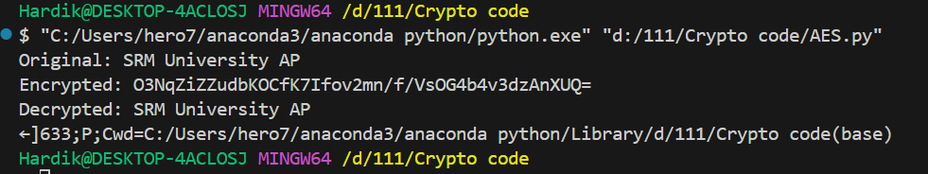

**RC4 Code**

def KSA(key):

    """Key Scheduling Algorithm"""

    key_length = len(key)

    S = list(range(256))

    j = 0

    for i in range(256):

        j = (j + S[i] + key[i % key_length]) % 256

        S[i], S[j] = S[j], S[i]

    return S

def PRGA(S):

    """Pseudo-Random Generation Algorithm"""

    i = 0

    j = 0

    while True:

        i = (i + 1) % 256

        j = (j + S[i]) % 256

        S[i], S[j] = S[j], S[i]

        K = S[(S[i] + S[j]) % 256]

        yield K

def RC4(key, plaintext):

    key = [ord(c) for c in key]

    S = KSA(key)

    keystream = PRGA(S)

    res = []

    for c in plaintext:

        val = ("%02X" % (ord(c) ^ next(keystream)))

        res.append(val)

    return ''.join(res)

def RC4_decrypt(key, ciphertext_hex):

    key = [ord(c) for c in key]

    S = KSA(key)

    keystream = PRGA(S)

    ciphertext_bytes = bytes.fromhex(ciphertext_hex)

    res = ''.join(chr(b ^ next(keystream)) for b in ciphertext_bytes)

    return res

key = "secretkey"

plaintext = "SRM University AP"

print("Original:", plaintext)

encrypted = RC4(key, plaintext)

print("Encrypted (hex):", encrypted)

decrypted = RC4_decrypt(key, encrypted)

print("Decrypted:", decrypted)

**Output:**

